RIPHAH INTERNATIONAL UNIVERSITY



NAME | ALIZA SHAHID
SAP ID | 56264
PROGRAMME | BSCS 3RD SEMESTER
COURSE | WEB DEVELOPMENT
LAB | 02 (Class Work)
SUBMITTED TO | MAM NAYAB KHALID

Class Work

Code:

<!DOCTYPE html>
<html>
<head>
<meta charset="UTF-8" />
<title>RIU</title>
</head>
<body>
!-<Class--1>
<body style="background-color: orchid;"></body>
<a href="https://www.pinterest.com/">This is a Link</a>
<img src="c:\Users\Aliza\Pictures\Henna.jpeg">
<br>
<p>Civil engineering is a professional discipline focused on designing, constructing, and maintaining the physical environment, encompassing public works like roads, bridges, canals, dams, airports, sewage systems, pipelines, and structural components of buildings, essentially shaping the built infrastructure that supports society. <br> It draws on principles of physics, mathematics, and materials science to plan, analyze, and oversee construction projects, often collaborating with other engineering disciplines and government agencies to ensure the functionality and safety of these vital structures across various scales, from small local projects to large-scale national developments. </p>
<b>Bold Text</b>
<br>
<strong>Henna Important Text</strong>
<br>
<i>Henna is Beautiful</i>
<br>
<em>Henna Emphaized Text</em>
<br>
<mark>Henna Mark Text</mark>
<br>
<small>Henna is Small</small>
<br>
<del>Delete Henna</del>
<br>
<ins>Henna is Inserted</ins>
<br>
<sub>Henna is Subscribed</sub>
<br>
<sup>Henna is SuperScribed</sup>
<br>
<h2>An unordered HTML List </h2>
<ul>
<li>Biryani</li>
<li>BBQ</li>
<li>Karahi</li>
</ul>

<h2>An Ordered HTML List </h2>
<ol>
<li>Biryani</li>
<li>BBQ</li>
<li>Karahi</li>
</ol>

</Class--1>

</body>
</html>

Website:

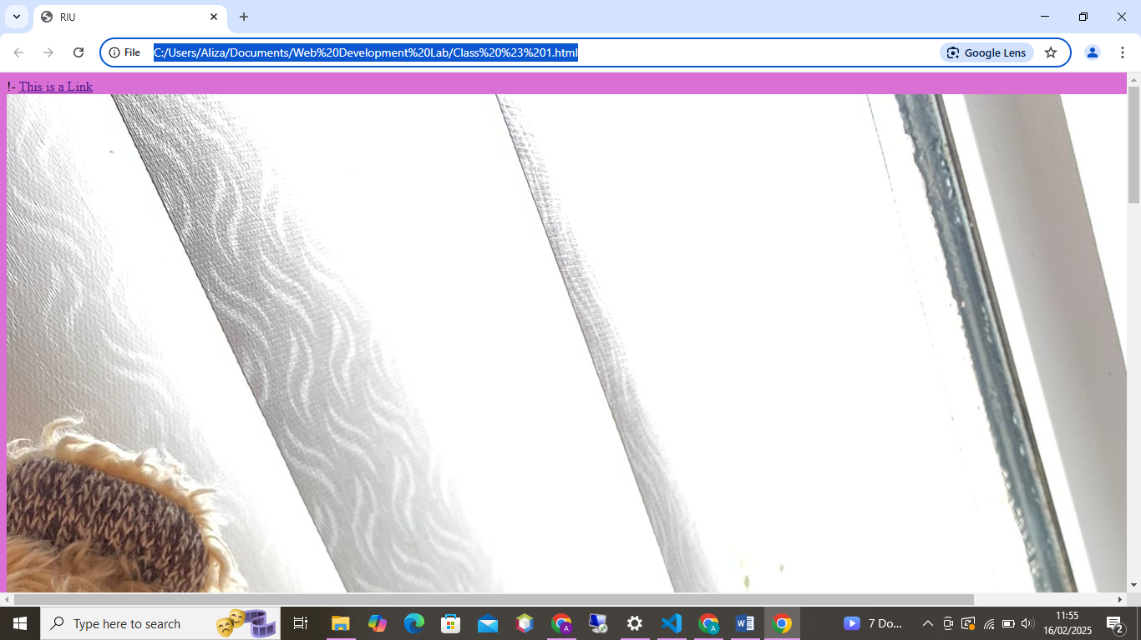

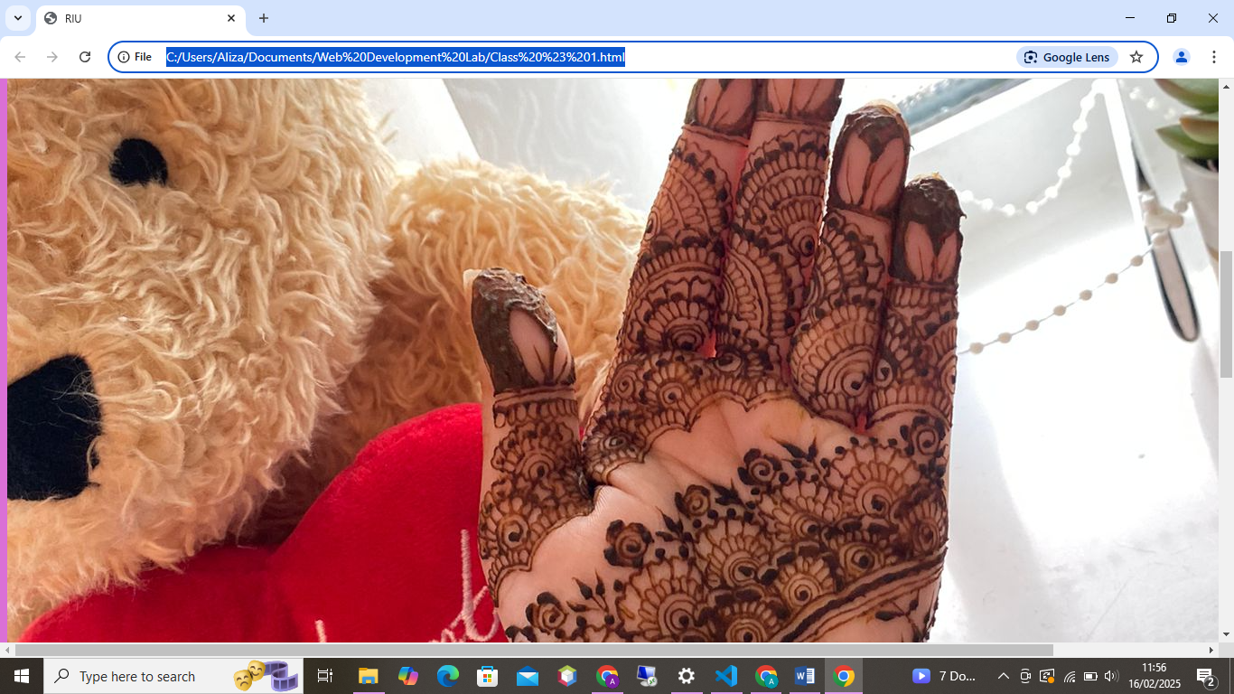

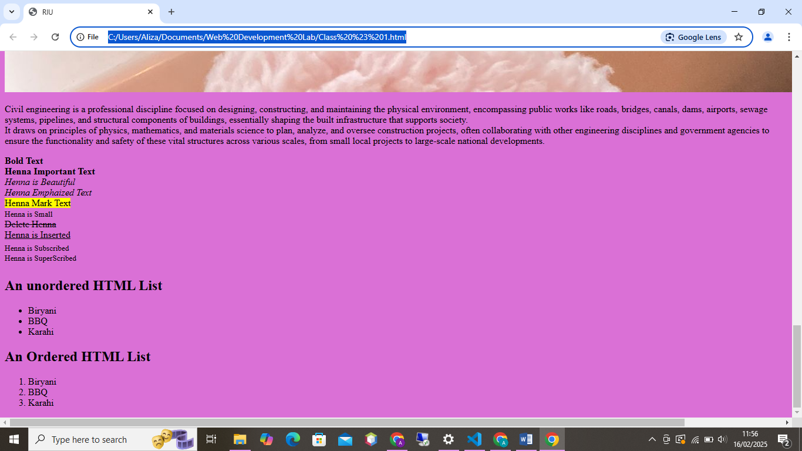

THE END!!

